**Q.1) Generate the summary statistics for each variable in the table. (Use Data analysis tool pack). Write down your observation.**

**Ans**

## calculate summary statistics using the data analysis tool pack.

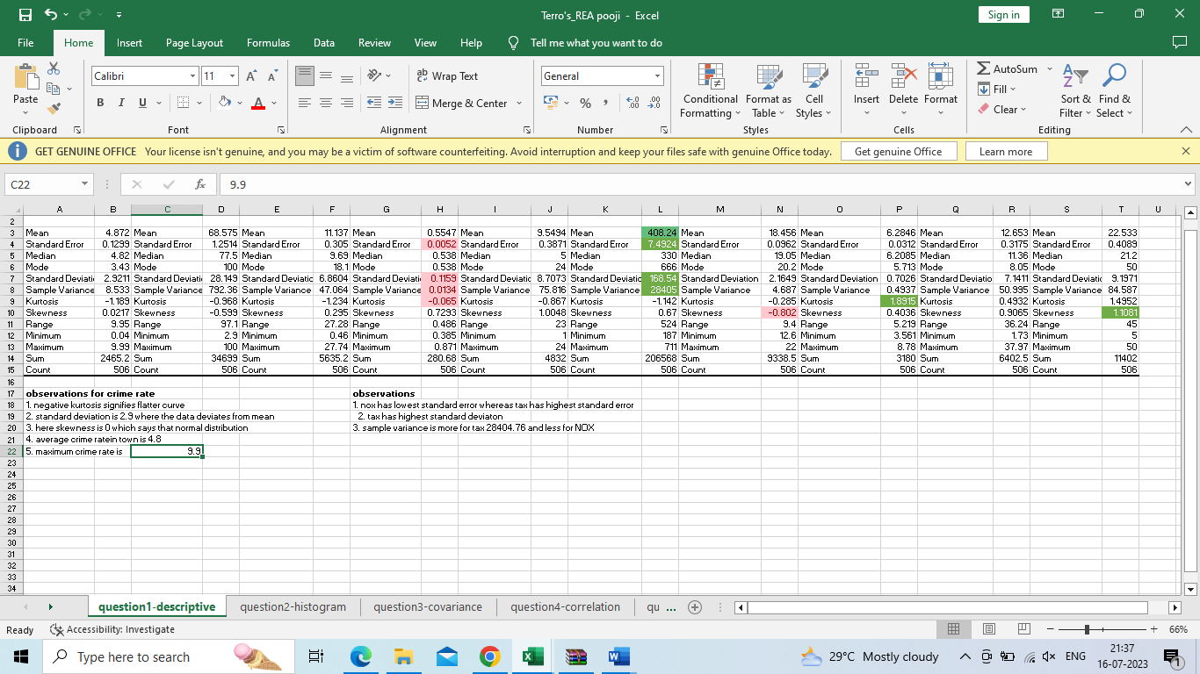

1. The mean values range for all variables from 0.55 to 408.24, indicating a wide range of values among the variables.
2. The standard errors of variables are relatively small, which suggests that the sample means are likely representative of the population means.
3. The medians of variables are generally close to the means, indicating that the distributions are likely symmetric.
4. The standard deviations of variables range from 0.7 to 168.54, indicating a wide range of variability among the variables.
5. The ranges of variables are also wide, ranging from 0.49 to 524.
6. The kurtosis and skewness values vary among the variables, suggesting that some of the distributions may be more or less peaked, and more or less skewed, than a normal distribution.
7. The minimum and maximum values also vary among the variables, providing additional information on the range of values and potential outliers.

**2) Plot a histogram of the Avg_Price variable. What do you infer?**

**Ans**

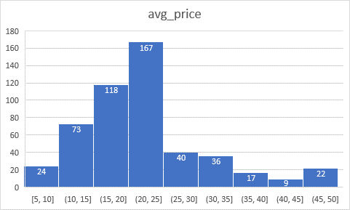

* The histogram shows the distribution of the data, where the x-axis represents the bins and the y-axis represents the frequency of the data points in each bin. We can see that the distribution is approximately normal with a few outliers.
* The mean and median of the data are close to each other, indicating that the data is approximately symmetric.
* The standard deviation of the data is likely to be moderate to high
* The data may be a combination of two or more underlying distributions, one with a lower mean and another with a higher mean.
* There are a few outliers on the right side of the distribution, which may be the result of errors in data collection or a separate underlying distribution with higher values.

**3) Compute the covariance matrix. Share your observations**

**Ans**

* If the covariance between two variables is zero, it suggests that there is no linear relationship between them. So hear some variable that are covariance between two variables is zero Crime_rate & Avg_room , nox & crime rate , LSTAT & Nox and some other.
* **If the covariance is negative, it suggests that the variables tend to move in opposite directions. Avg_room & Age , avg_price & age , indus & avg_price , tax & Crime _rate**

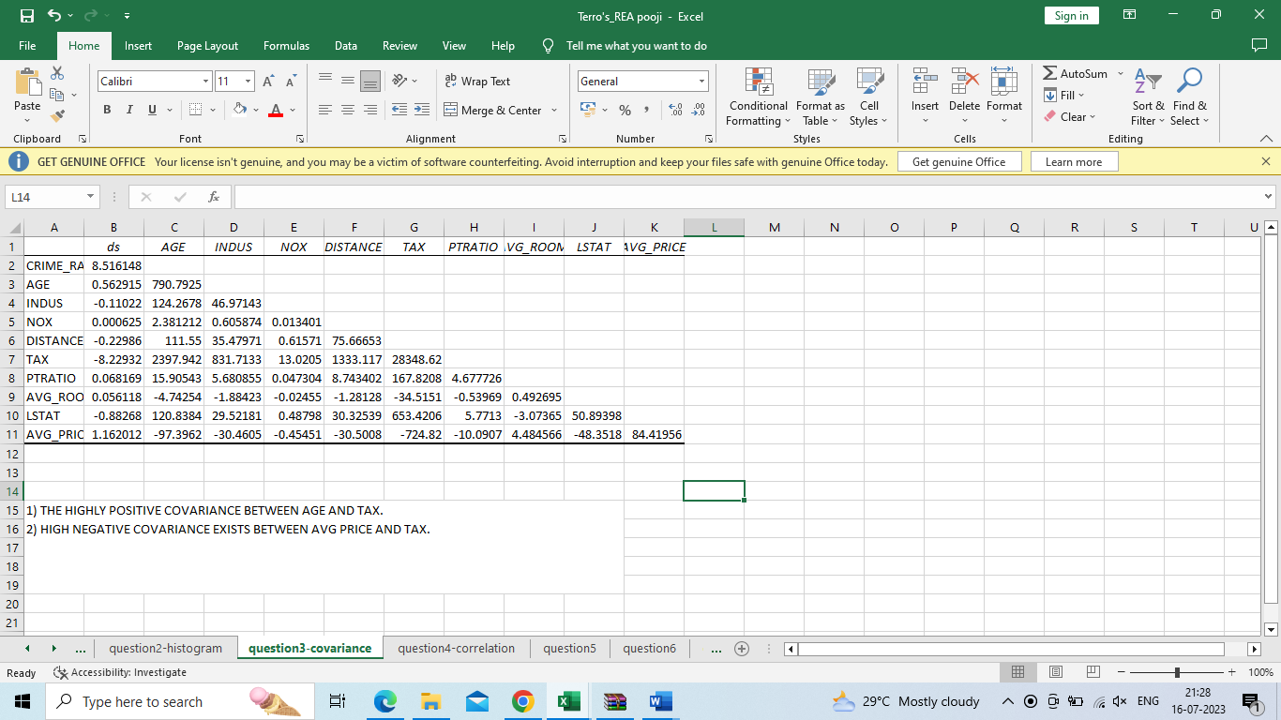

* **If the covariance between two variables is very large or very small, it suggests that there may be a strong linear relationship between them.**

**4) Create a correlation matrix of all the variables (Use Data analysis tool pack). (5 marks) a) Which are the top 3 positively correlated pairs and b) Which are the top 3 negatively correlated pairs.**

Ans:

The correlation coefficient is a number between -1 and 1 that quantifies the strength of the correlation. A correlation coefficient of “1” indicates a perfect positive correlation, while a correlation coefficient of “-1” indicates a perfect negative correlation. A correlation coefficient of 0 indicates no correlation between the variables.

1. Which are the top 3 positively correlated pairs.
2. Which are the top 3 negatively correlated pairs.

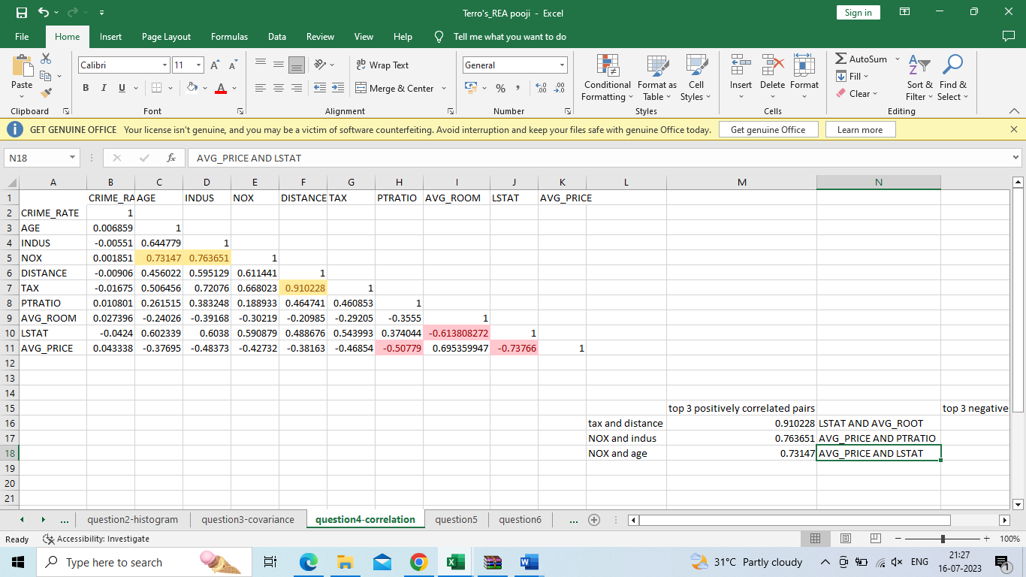

**5) Build an initial regression model with AVG_PRICE as ‘y’ (Dependent variable) and LSTAT variable as Independent Variable. Generate the residual plot.**

**a) What do you infer from the Regression Summary output in terms of variance explained, coefficient value, Intercept, and the Residual plot?**

**Ans**

Regression Summary output provides valuable information about the relationship between the dependent variable and the independent variables in a linear regression model.

* Regression model R-squared value of 0.544146298 indicates that your initial regression model explains 54.4% of the variation in the dependent variable, which is moderate.
* Regression model coefficient values between Intercept & coefficient is 34.55384088 is positive relationship and coefficient & LSTAT is -0.950049354 is negative relationship
* The intercept in regression model is 34.55384088. This represents the estimated value of the dependent variable (Y) when all the independent variables (X) in the model are equal to zero.

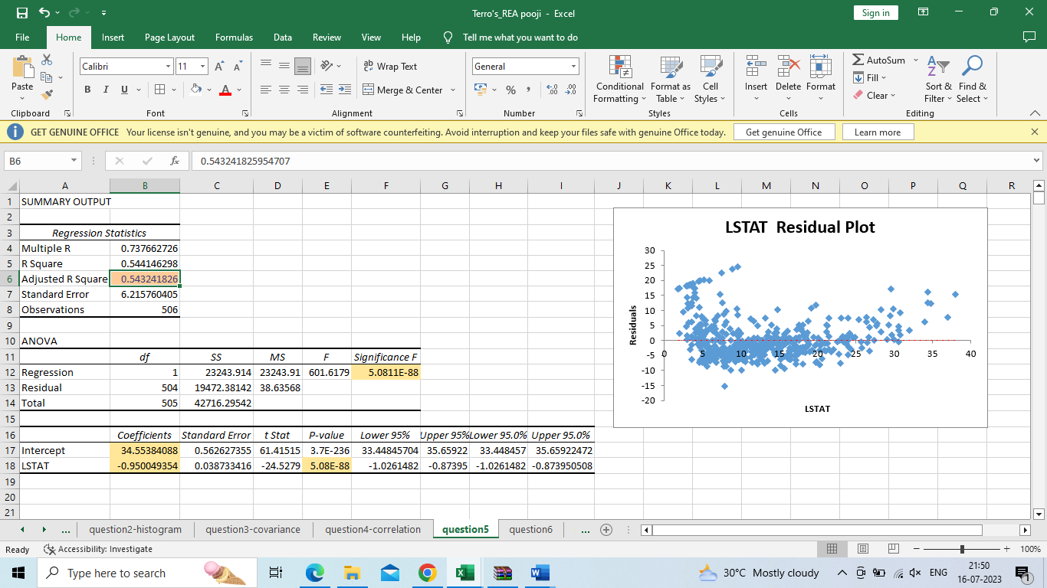

**b) Is LSTAT variable significant for the analysis based on your model.**

Based on the regression model summary, the LSTAT variable is significant for the analysis. The p-value for the LSTAT coefficient is less than 0.05, which is the commonly used significance level. This means that there is strong evidence that the LSTAT variable has a significant linear relationship with the average house price.

**6) Build a new Regression model including LSTAT and AVG_ROOM together as independent variables and AVG_PRICE as dependent variable.**

**a) Write the Regression equation. If a new house in this locality has 7 rooms (on an average) and has a value of 20 for L-STAT, then what will be the value of AVG_PRICE? How does it compare to the company quoting a value of 30000 USD for this locality? Is the company Overcharging/ Undercharging?**

REGRESSION EQUATION: y=(m1*7)+(m2*20)+b

To find the predicted value of AVG_PRICE for a new house with 7 rooms and LSTAT value of 20, we substitute these values in the regression equation:

AVG_PRICE = -1.35 + (-0.64 * 20) + (5.09 * 7) AVG_PRICE = -1.35 – 12.8 + 35.63 AVG_PRICE = 21.48

So, the predicted value of AVG_PRICE for a new house with 7 rooms and LSTAT value of 20 is 21,480 USD.

If the company is quoting a value of 30,000 USD for this locality, then the predicted value is much lower than the quoted value. It suggests that the company might be overcharging for the houses in this locality.

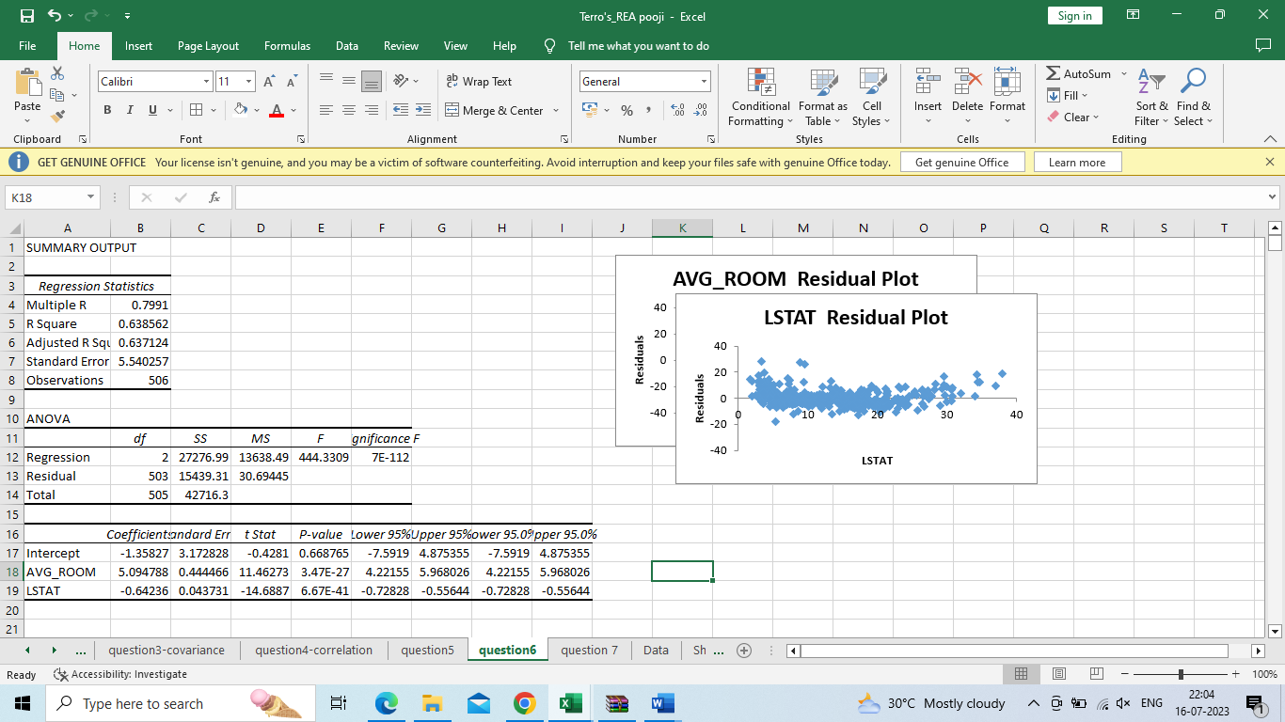

b) Is the performance of this model better than the previous model you built in Question 5? Compare in terms of adjusted R-square and explain?

1. Yes, the performance is better, and the adjusted R square value has improved. Because in the previous question only one independent variable was taken into consideration, this question considers two independent variables, which has a lower P-value.

Comparing the adjusted R-squared values, we can see that the new model with “LSTAT” and “AVG_ROOM” as independent variables have a higher adjusted R-squared value of 0.637 compared to the previous model adjusted R-squared of 0.543. This indicates that the new model is a better fit for the data than the original model

**Q. 7) Build another Regression model with all variables where AVG_PRICE alone be the Dependent Variable and all the other variables are independent. Interpret the output in terms of adjusted Rsquare, coefficient and Intercept values. Explain the significance of each independent variable with respect to AVG_PRICE. (8 marks)**

Ans

The multiple regression model has an adjusted R square of 0.688, which means that 68.8% of the variation in the dependent variable (AVG_PRICE) can be explained by the independent variables in the model.

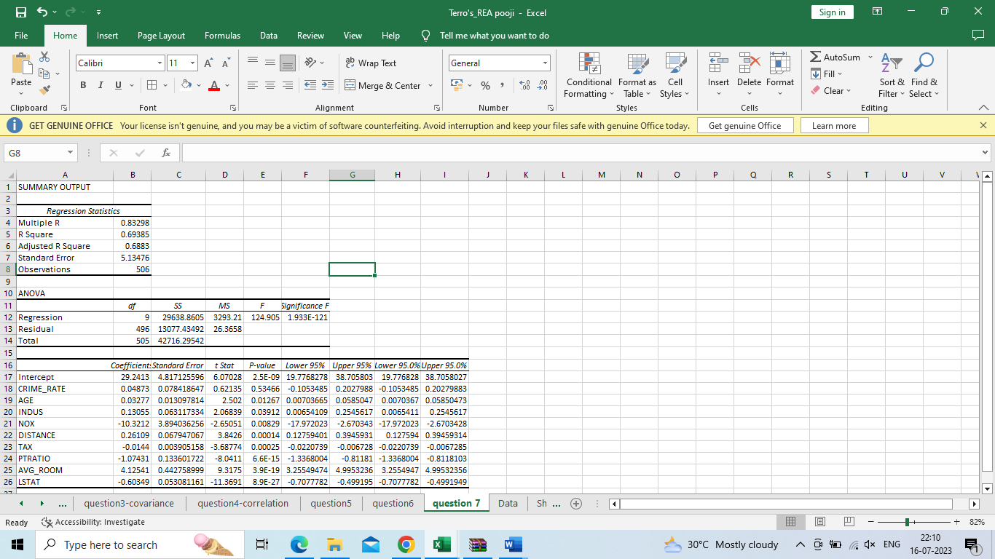

The p-value associated with each coefficient can be used to determine whether that variable is a statistically significant predictor of AVG_PRICE.

Based on the p-values listed in the output, the following independent variables are statistically significant predictors of AVG_PRICE:

* AVG_ROOM: A one-unit increase in the average number of rooms per dwelling is associated with an increase in AVG_PRICE of 4.13 units (p < 0.001).
* LSTAT: A one-unit increase in the percentage of lower status of the population is associated with a decrease in AVG_PRICE of 0.60 units (p < 0.001).
* PTRATIO: A one-unit increase in the pupil-teacher ratio is associated with a decrease in AVG_PRICE of 1.07 units (p < 0.001).
* DISTANCE: A one-unit increase in the weighted distances to five Boston employment centres is associated with a decrease in AVG_PRICE of 0.26 units (p < 0.001).
* TAX: A one-unit increase in the full-value property-tax rate per $10,000 is associated with a decrease in AVG_PRICE of 0.01 units (p < 0.001).
* NOX: A one-unit increase in the nitric oxide’s concentration is associated with a decrease in AVG_PRICE of 10.32 units (p < 0.001).

**8) Pick out only the significant variables from the previous question. Make another instance of the Regression model using only the significant variables you just picked and answer the questions below: (8 marks)**

**a) Interpret the output of this model.**

**b) Compare the adjusted R-square value of this model with the model in the previous question, which model performs better according to the value of adjusted R-square?**

**c) Sort the values of the Coefficients in ascending order. What will happen to the average price if the value of NOX is more in a locality in this town?**

**d) Write the regression equation from this model.**

**Ans:**

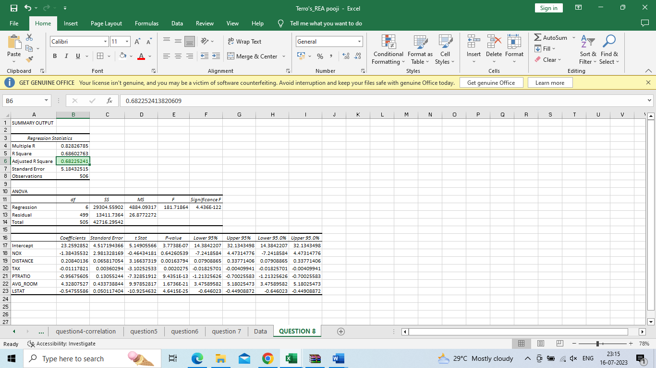

**1. Write the regression equation from this model.**

Ans: Response variable = 23.25928523 - 1.384355318 * NOX + 0.208401356 * DISTANCE - 0.011178212 * TAX - 0.95675605 * PTRATIO + 4.328075271 * AVG_ROOM - 0.54755586 * LSTAT

**2) Sort the values of the Coefficients in ascending order. What will happen to the average price if the value of NOX is more in a locality in this town?**

**Ans:** Sorting the coefficients in ascending order based on their absolute values:

1. TAX: -0.011178212
2. NOX: -1.384355318
3. PTRATIO: -0.95675605
4. LSTAT: -0.54755586
5. DISTANCE: 0.208401356
6. AVG_ROOM: 4.328075271
7. Intercept: 23.25928523

Based on this ordering, the predictor variable with the smallest absolute coefficient value is "TAX", while the predictor variable with the largest absolute coefficient value is "AVG_ROOM".

Regarding the effect of NOX on the average price in the town, we can look at the coefficient of the "NOX" predictor variable, which is -1.384355318. This means that, holding all other variables constant, for every one-unit increase in NOX, the average price of houses in the town is expected to decrease by 1.38436

**3) Compare the adjusted R-square value of this model with the model in the previous question, which model performs better according to the value of adjusted R-square?**

**Ans:**

Comparing the adjusted R-squared values, we can see that the new model have a lower adjusted R-squared value of 0.682 compared to the previous model adjusted R-squared of 0.688. This indicates that the previous model is a better fit for the data than the original model.

**4) Write the regression equation from this model.**

Y=M1X1+M2X2+MX3+M4X4+M5X5+M6X6+M7X7+B